Basic Inputs:
1. Age
2. Monthly income
3. Monthly committed expenses
4. Investment horizon
Short (<3y) / Medium (3–7y) / Long (7y+)
5. Self-declared risk comfort

Internal framework factors:
- Surplus Income Ratio (SIR)
- Liquidity Preference Score (LPS)
- Time Horizon Cluster (THC)
- Risk Disposition Index (RDI)
- Tax Efficiency Score (TES)

Portfolio group segration:

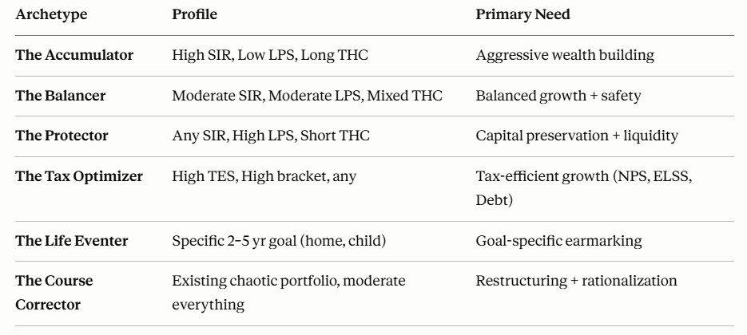

Asset allocation framework
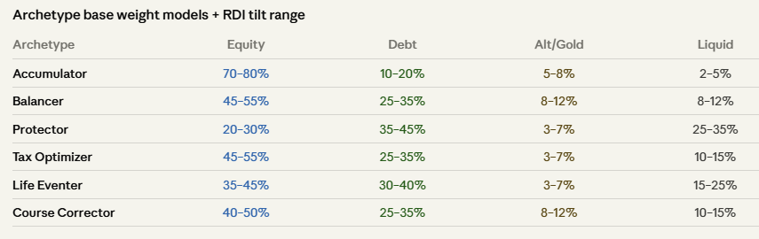

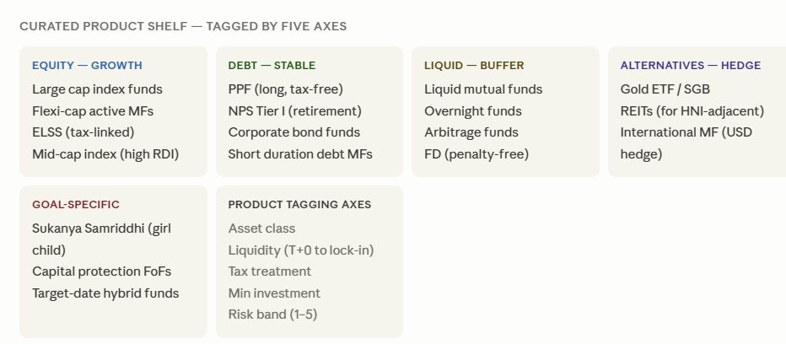

Rebalancing Engine
Trigger 1 — Drift Rebalancing
- Cash flow Calendar
- Strategic Asset Allocation – time based (half yearly/annual)
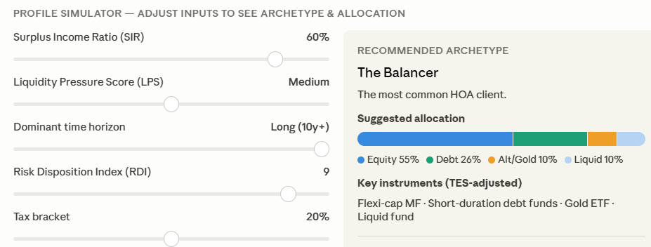

Trigger 2 — Market Regime Overlay (Valuation + Macro)
Nifty PE / PB vs. historical percentile — if PE is in the 90th percentile of last 15 years, markets are expensive; reduce equity tilt
- India VIX level — elevated VIX signals stress; affects whether the tilt is defensive or neutral
- Macro regime flag — a simple 3-state flag (expansion / neutral / contraction)

Exact Output:
Model portfolio allocation with products breakup
Existing portfolio
Action plans on changes
- What to redeem
- What to reinvest

Example - Edel Arb Fund – Car pic

